ASSIGNMENT 2 JAVASCRIPT

Que 1: What is the output of this snippet of code:

!DOCTYPE html>

<html lang="en">

<head>

    <meta charset="UTF-8">

    <meta name="viewport" content="width=device-width, initial-scale=1.0">

    <title>Document</title>

    <script>

        function foo() {

            x = 1;

            function x() { }

            var x = '2';

            return x;

        }

        alert(typeof foo());

    </script>

</head>

<body>

</body>

</html>

OUTPUT:

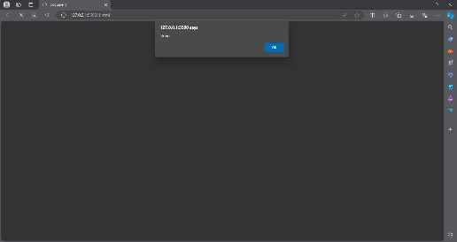

QUE2: What is the output of this snippet of code?

<!DOCTYPE html>

<html lang="en">

<head>

    <meta charset="UTF-8">

    <meta name="viewport" content="width=device-width, initial-scale=1.0">

    <title>Document</title>

    <script>

      function foo() {

    return x;

    x = 1;

    function x() { }

    var x = '2';

}

console.log( typeof foo() );

    </script>

</head>

<body>

</body>

</html>

OUTPUT:

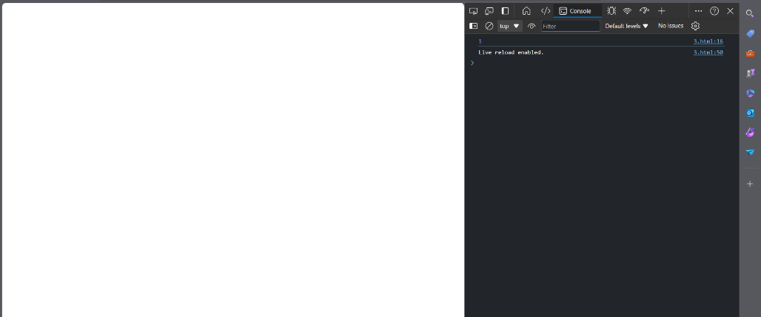

QUE:3 What is the output of this snippet of code

<!DOCTYPE html>

<html lang="en">

<head>

    <meta charset="UTF-8">

    <meta name="viewport" content="width=device-width, initial-scale=1.0">

    <title>Document</title>

    <script>

        var x = 1;

function foo() {

    x = 10;

    return;

    function x() {}

}

foo();

console.log( x );

    </script>

</head>

<body>

</body>

</html>

OUTPUT: